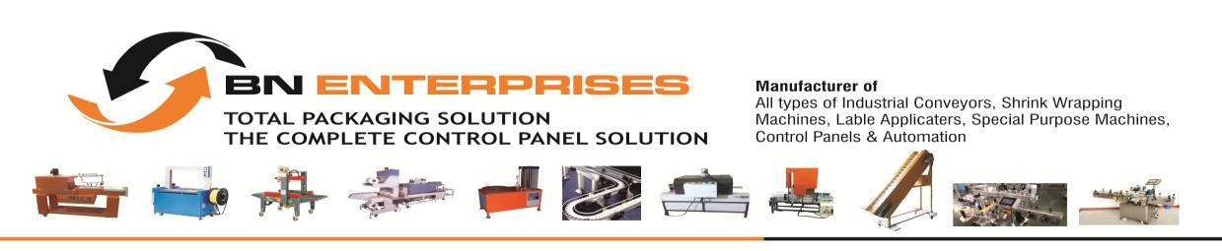
Factory: Gate No.20 ARVI Village Near Khedshivapur Industrial Estate Tal Haveli Pune-412205
GREETING FROM B N ENTERPRISES AN ISO 9001:2015 CERTIFIED COMPANY.
Quotation

Ref No/Qty No: BN/21693/2022-2023 Date: 16.09.2022
GST NO-27ANGPC6263Q1ZI
To,

NIHVA Technologies Pvt. Ltd
Add:
Mob: 7219207333
Email: procurement@nihva.com
Kind Attn: Mr. Prasad J Deshmukh Sir

Sub: Offer for Random Carton Taping Machine Model No-BNE-6050-R
Dear Sir,

This is with refers to your telecom held with our Mr. Choure Sir regarding your requirement for
Random Carton Taping Machine Model No-BNE-6050-R
We are submitting
Herewith our techno commercial Offer for your perusal.Our valued clients include Mahindra and Mahindra Limited, Coca Cola, Tirumalla Oil Refinery Pvt. Ltd., Century Enka Limited, Savera Auto Comps Pvt. Ltd., Candigra Vision Process Equipment’s Pvt. Ltd., Eton Industrial Systems Pvt. Ltd., Garaware Ropes Limited, Talbros Automotive Components Limited, Bakelite Food Processing Equipment’s Pvt. Ltd., Fulham India Pvt. Ltd., Feather feel Nonwoven Pvt. Ltd., Woodward India Pvt. Ltd., Fluid Controls Pvt. Ltd., Brainbees Solution Pvt. Ltd. Retier India Pvt. Ltd. Inoxpa India Pvt. Ltd. Nihva Technologies Pvt Ltd., Shirodkar Preci Comp, Zusamen Lifescience & Resurch Pvt Ltd, Avi Globle Plast Pvt Ltd.,
Pacco Automation India Private Limited., Crunch Affair Foods Private Limited., Elixir Soltek Pvt. Ltd., Sohum Foods., Vishal Foods., Parthprachet Industries etc.
We hope you will find the offer in line of your requirement. If you need any further techno commercial clarifications please feel free to contact us.

Waiting for your favorable reply at earliest, Assuring for the best and personal attention at all times, With Best regards,


Choure B.
Cell: +91-8308746511, +91-8308773422
+91-9607993692
Email: inf.bnenterprises@gmail.com / sales@bnenterprises.net

Random Carton Taping Machine Model No-BNE-6050-R

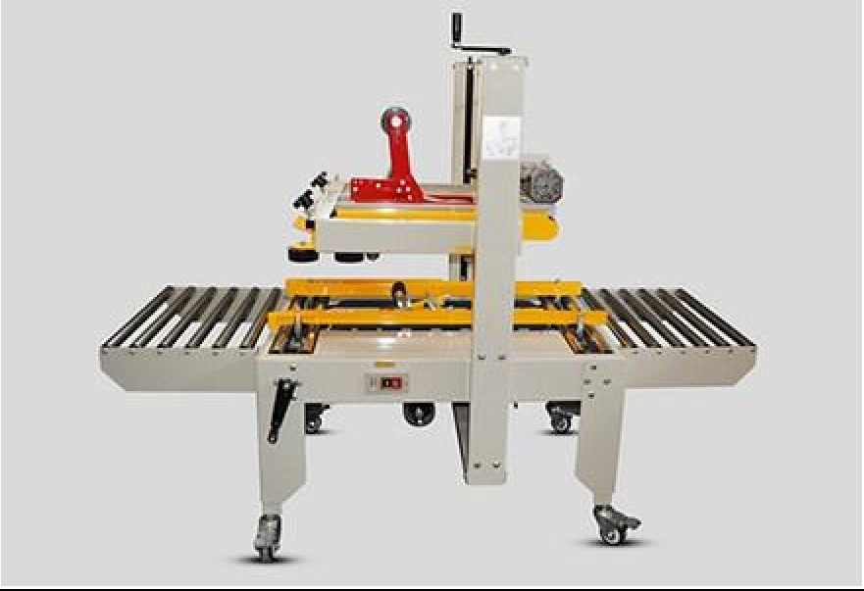

- Max.packing dimension 795(W)* 750(H)* ANY SIZE (L)mm
- Min.packing dimension 200(W)*160 (H)*200 (L)mm
- Tape Size- 3 Inch
- Working Height- 750mm-(it should be adjustable up to +/- 100 mm)
- Speed Expectations – Min 18 Carton / Min
- Describe shortly @ Packing Operation – Carton Packing on Tables Placement on Roller Conveyor
- Height And Width Automatic Adjustable Length Any Size

Voltage (V/Hz) | 220 / 50
Available Adhesive Tape | BOPP, water free adhesive tape, PVC adhesive tape
Height of Table (mm) | 635 - 780
Width of Adhesive Tape (mm) | 48 60 76
Size (LxWxH) mm | 1755 x 740 x (1445 – 1605)
Weight (kg) | 120

PRICING STRUCTURE OF EQUIPMENT:

Sr. No. | Machine Name / Model | HSN CODE | Qty. | Rate For Each Price in INR | Total Rate Price in INR
1. | Random Carton Taping Machine Model No- BNE-6050-R |  | 01 | 2,05,000.00 | 2,05,000.00

Terms and Conditions:

Price Basis | The above prices are Ex Works, exclusive of all applicable taxes & duties.
Payment Terms | 50 % advance payment along with the purchase order.  50 % balance payment against Performa Invoice before dispatch.
Delivery | 20 days from the date of receiptof confirmed purchase order or from the date of receipt of  the advance payment or from the date of receipt of the samples whichever is later.
Mode of Transport | BY Road, Freight – “TO PAY” Basis.
Taxes | 18% extra GST
Packing | 4 % for Box packing.
Insurance | To be borne by customer OR Covered by B.N.ENTERPRISES @ 0.50% on the basic value.
Inspection | At our works before dispatch at your cost.
Manual | Machine instruction manual will be supplied free of cost.
Jurisdiction | In case of any dispute/s all the claims are subjects to Pune Jurisdiction only.
Cancellation | Once we confirm the technically & commercially clear order, we will take up the manufacture of the machine immediately in hand. Hence, we cannot accept any changes or cancellation of order and thus we cannot refund your advance amount back to you. The placing of an order with us implies acceptance of the conditions of sale here in stated  regardless of any constricting clauses in the Buyers purchase order.
Warranty | We provide warranty of 12 months from the date of dispatch against manufacturing  defects Or default workmanship. Warranty does not cover any electric or electronic parts such as AC variable drive, motor, PLC, sensor, relay etc.
Special Note | If the machine is not picked up after the final inspection (Beyond the delivery time) by you then we will charge 1.5% per week for the basic value of the machine and it has to be  cleared before the Machine dispatch.
Validity | 30 days from the date of quotation.
Important Installation Commissioning Terms And Conditions:
Inspection &  Training | FAT at our works before dispatch. It is COMPULSORY that your technician is trained at our  works for three days prior to dispatch of the machinery. A skilled technician is necessary for the same. We shall provide all the necessary training regarding the working/maintenance of the machine, the training charges will be free but the lodging and boarding and conveyance etc of our technician will be borne by you. If your operator is not trained we are not responsible for the satisfactory working of the machine.
Installation&  Commissioning | The cost of installation and commissioning will be Rs. 5,000/- per person, per day plus to and  fro charges for the visit. Before the visit of the technician, please ensure that all civil and ancillary works are completed. Samples of bottles, caps, label rolls should be available in sufficient quantity. In case the above is not ready during the visit of our technician, they will go back, and RE-VISIT charges will be to your account. Customer has to provide the required samples (bottles, caps, Ampoule, Label etc) required in the trial of the machine at his cost.  Quantity of the samples will be mentioned prior to the trial. Please make sure the trail Samples are arranged in advance so this may not delay the delivery time. Or the delivery time  scheduled in the quotation will not be valid.
Any addition other than the basic/standard machine details mention in the quotation will cost extra. This quotation cancels all the previous given quotation. Note: As per the Company rules the Compa ny have right to change the specification/design for the better functioning of the machine.

